Name: Rodriguez, Michael SDEV300 Date: (12/16/2022)

**Test Note:** Commas in input indicate the next input attempt for that value.

**Test Case: Logging Failed Logins**

|  |  |  |
| --- | --- | --- |
| Input | Expected Output | Actual Output |
| Username = ,  Floatinghair,  Floatinghair,  Floatinghair  Password = ,  ,  abd,  aA1!aaaaaaaa | The log file should have 3 failed login entries. An “Invalid Credentials” message should be displayed. I should be redirected back to the Login Page with each failed attempt. The final successful attempt should take me to the Home Page. | See below screenshots for Login Page, and network logs. |

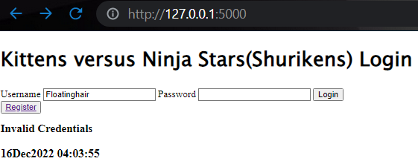

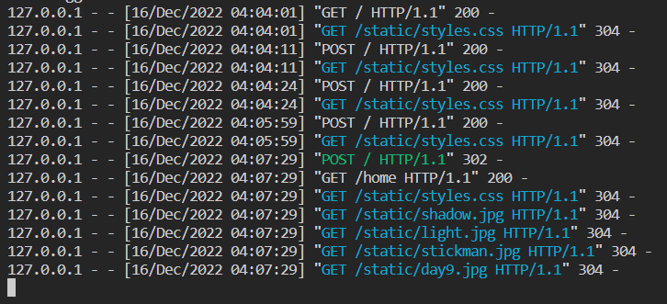

Note: This test case made me realize I had to catch the case if either the password or username was None or an empty string.I also had to find the remote_addr attribute of request to get the client IP. Current time needed to be called again for each log attempt or it would be whenever the page is loaded.

**Test Case: Update Password**

|  |  |  |
| --- | --- | --- |
| Input | Expected Output | Actual Output |
| Click new “Update Password” button on Home Page  Current Password = ,  a,  aA1!aaaaaaaa,  aA1!aaaaaaaa  New Password = ,  ,  password,  cC1!cccccccc  Confirm Password = ,  ,  password,  cC1!cccccccc | Update Password button should redirect me to the new Update Password Page. The Update Password Page should redirect me three times with an error. The final correct attempt should update the accountsFile.txt and redirect me to the Home Page. | Additional screenshots below. |

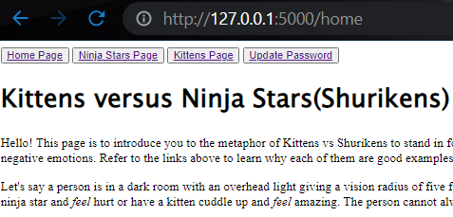

Above figure showcasing the new button.

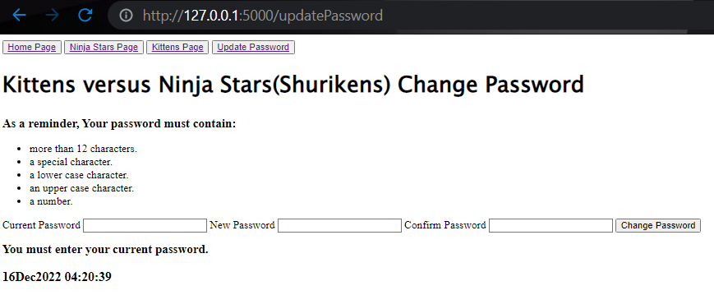

**Notes: Common passwords were checked for on an individual character level instead of by line. I added a \n in the case to correctly check by line.**

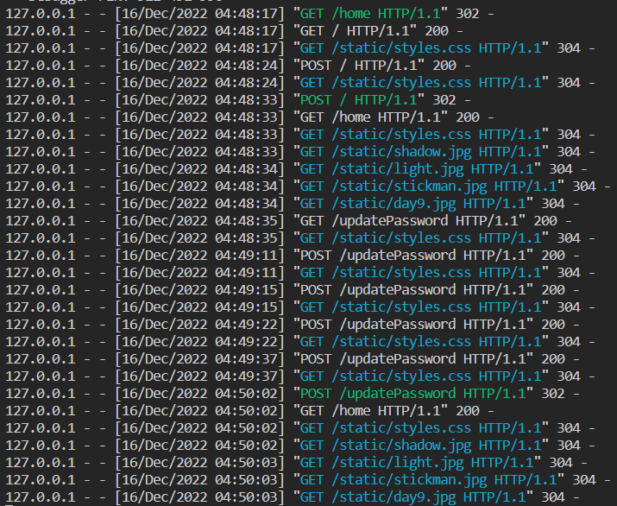

**Test Case: Registration Checks for Common Password**

|  |  |  |
| --- | --- | --- |
| Input | Expected Output | Actual Output |
| Username = Jeff,  Jeff  Password = password,  baseball,  gG1!gggggggg  Confirmed Password = password,  baseball,  gG1!gggggggg | The first inputs should error to not use a common password. The next set of inputs should correctly create the account. |  |

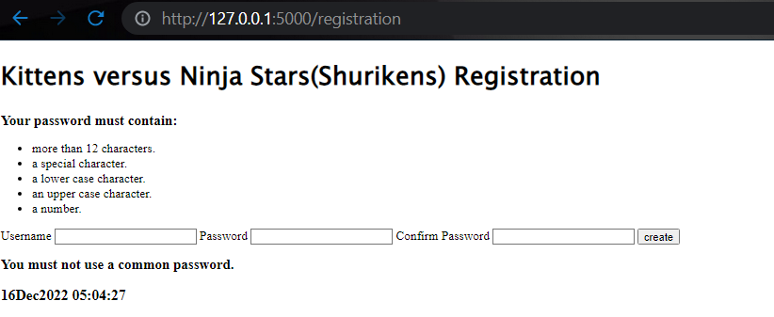

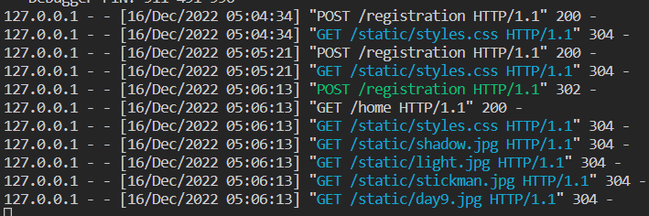

**Pylint:** 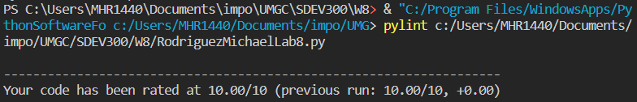

**Pylint Notes:** I had a previous issue with changing a global Boolean variable without a Pylint warning. I have since created a login object to track whether the user is logged in or not.

**Decryption Portion:**

1. - .... .. ... / ... -.. . ...- / ...-- ----- ----- / -.-. .-.. .- ... ... / .... .- ... / ... --- -- . / ... - .-. .- -. --. . / .-. . --.- ..- . ... - ... .-.-.-

Dots and Dashes are pretty synonymous with morse code. I used the morse code decrypter to get the plain text of:

“this sdev 300 class has some strange requests.”

1. U28gdGhpcyBpcyBiYXNlNjQuIE5vdyBJIGtub3cu

I recognized this encryption style being all clumped together with no special characters. I used the Base64 decoder to get the plain text of:

“So this is base64. Now I know.”

c. --- Psuwb Ysm ----

W oa gc qzsjsf. Bc cbs qcizr dcggwpzm twuifs hvwg cih.

--- Sbr Ysm ---

Caesar cipher was one of the mentioned encryptions, and the encryptions did not look that different with spaced out one or two letter combinations. I decrypted it with a 14 shift to get:

--- Begin Key ----

I am so clever. No one could possibly figure this out.

--- End Key ---